ETHICS OF ARTIFICIAL INTELLIGENCE TALK
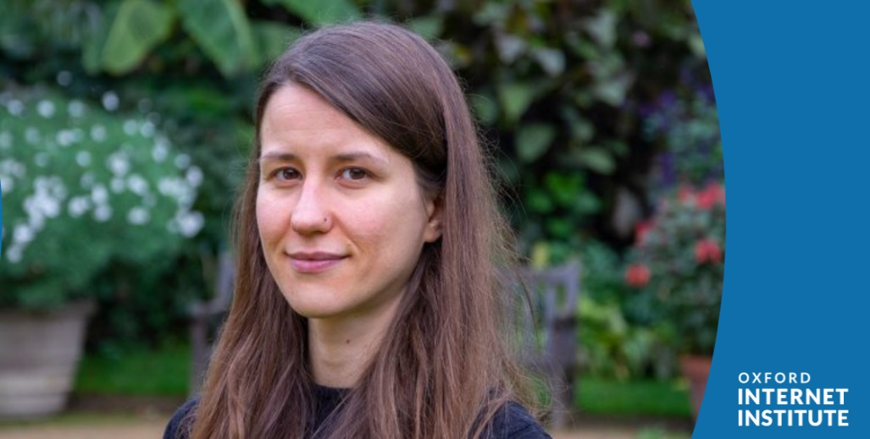

PROFESSOR SANDRA WACHTER

Professor Sandra Wachter is a senior research fellow at the University of Oxford Internet Institute. She works with the World Bank, European Commission, and the UK government, as well as other governments and NGOs around the world to advise on ethical questions concerning emerging technologies.
She will be speaking to us about the ethical issues surrounding A.I.

Tuesday May 10th 4:10-5pm
SHSK Lecture Theatre

